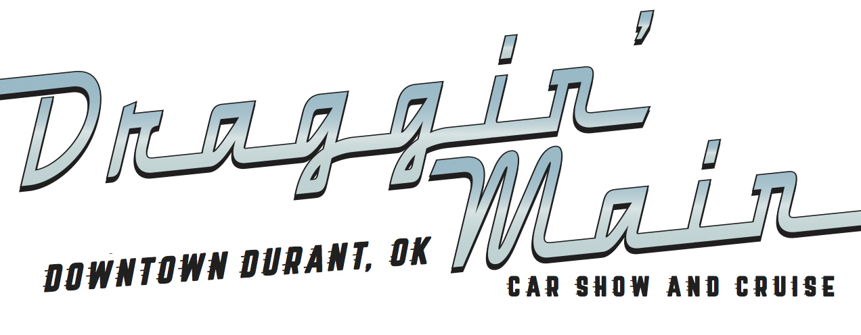

June 16 and 17
Sponsorship Packages

Presenting Sponsor- $7,500
At the event, your business will appear on the main stage banner, on the first line of the back of the t-shirts, listed on all car show trophy plaques and will be announced from the stage. You will receive a commemorative sponsor plaque, have the opportunity to speak from the main stage during opening ceremonies and setup a vendor booth at the car show. You will also receive three free entry registrations to the car show. Prior to the event, your business will be listed as top billing on promotional flyers, the Durant Main Street website, mentioned on radio, television, print, and social media advertisements.

Premier Sponsor- $3,500 (2 available)
At the event, your business will be listed on the main stage banner, on a banner in a high traffic area, and on the upper back of the t-shirt in large font, and will be announced from the event stage. You will receive a commemorative sponsor plaque, have the opportunity to speak from the main stage and setup a vendor booth at the car show. You will also receive two free entry registrations to the car show. Prior to the event, your business will be listed on the Durant Main Street website, mentioned on radio, print, and social media advertisements.

Trophy Sponsor- $3,000
At the event, your business will be listed on the main stage banner, on car show trophy plaques, and on the back of the t-shirt in medium font, and will be announced from the stage, where you can help award trophies to our car show winners. You will receive a commemorative sponsor plaque and have the opportunity to setup a vendor booth at the car show. You will also receive one free entry registration to the car show. Prior to the event, your business will be listed on the Durant Main Street website, mentioned on print and social media advertisements.

Entertainment Sponsor- $3,250 (2 Available)
At the event, your business will be listed on the main stage banner and on the back of the t-shirt in medium font, and will be announced from the stage, where you can introduce the band. You will also receive two free entry registration to the car show. You will receive a commemorative sponsor plaque and have the opportunity to setup a vendor booth at the car show. Prior to the event, your business will be listed on the Durant Main Street website and mentioned on print and social media advertisements.

Best of Show Prize Sponsor- $1,500
At the event, your business will have the opportunity to present the Best of Show cash prize, be listed on the back of the t-shirt in medium font, on the main stage banner, and will be announced from the stage. You will also receive one free entry registration to the car show. You will receive a commemorative sponsor plaque and have the opportunity to setup a vendor booth at the car show. Prior to the event, your business will be listed on the Durant Main Street website and mentioned on print and social media advertisements.

T-Shirt Sponsor- $1,500 (2 available)
At the event, your business will be listed on the back of the t-shirt in medium font and on the main stage banner, and will be announced from the stage. You will also receive one free entry registration to the car show. You will receive a commemorative sponsor plaque and have the opportunity to setup a vendor booth at the car show. Prior to the event, your business will be listed on the Durant Main Street website and mentioned on print and social media advertisements.

Tailgate Party Sponsor- $1,000
At the event, your business will have the opportunity to award the trophy for the best Tailgate Party, be listed on the back of the t-shirt in medium font and on a banner within the Tailgate Party event perimeter, and your business will be announced from the stage. You will also receive one free entry registration to the car show. You will receive a commemorative sponsor plaque and have the opportunity to setup a vendor booth at the car show. Prior to the event, your business will be listed on the Durant Main Street website and mentioned on print and social media advertisements.

Burnout Contest Sponsor- $1,000
At the event, your business will have the opportunity to welcome the crowd at the Burnout Contest, be listed on a banner in the Burnout area, and on the back of the t-shirt in medium font, and will be announced from the stage. You will also receive one free entry registration to the car show. You will receive a commemorative sponsor plaque and have the opportunity to setup a vendor booth at the car show. Prior to the event, your business will be listed on the Durant Main Street website and mentioned on print and social advertisements.

T-Shirt Booth Sponsor - $500
At the event, your business will be listed on the back of the t-shirt in small font, and on a banner within the event perimeter. You will also receive one free entry registration to the car show. You will receive a commemorative sponsor plaque and have the opportunity to setup a vendor booth at the car show. Prior to the event, your business will be listed on the Durant Main Street website and mentioned on social media advertisements.

Kruisin’ for Kids Junior Car Show Sponsor-$1500 (1 Available)
At the event, your business will appear on the Junior Car Show Banner, on the back of the Junior Car Show t-shirts, listed on all Junior car show trophy plaques and will be announced from the stage. You will receive a commemorative sponsor plaque. You will also receive one free entry registration to the car show. Prior to the event, your business will be listed on promotional flyers, the Durant Main Street website, mentioned on radio, television, print, and social media advertisements.

Wet & Wild Bounce House Sponser-$600 (5 Available)
At the event, your business will appear on signage directly beside sponsored bounce house. on the back of the Junior Car Show t-shirts, listed on all Junior car show trophy plaques and will be announced from the stage. Prior to the event, your business will be listed on promotional flyers, the Durant Main Street website, mentioned on radio, television, print, and social media advertisements.

Draggin’ Main General Sponsor - $500 (20 available)
At the event, your business will be listed on the back of the t-shirt in small font, and on a banner within the event perimeter. You will also receive one free entry registration to the car show. Prior to the event, your business will be listed on the Durant Main Street website and mentioned on social media advertisements. You will receive a commemorative sponsor plaque and have the opportunity to setup a vendor booth at the car show.
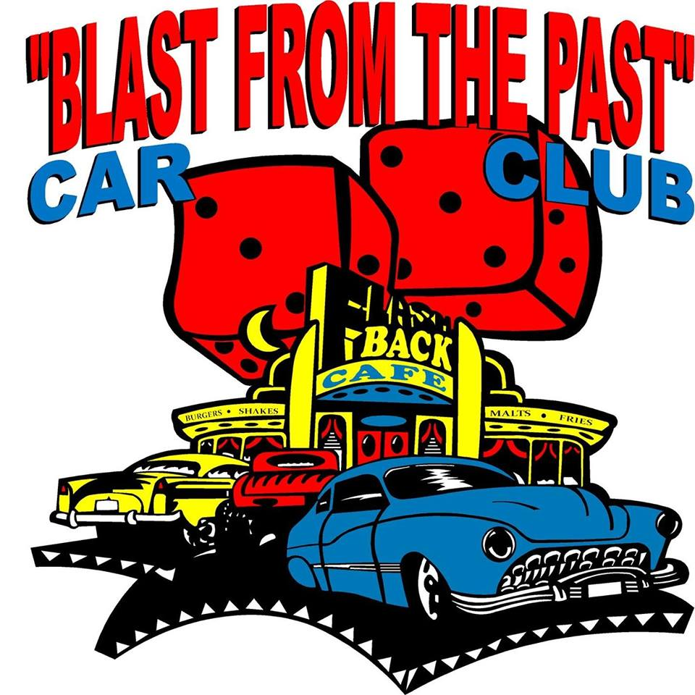
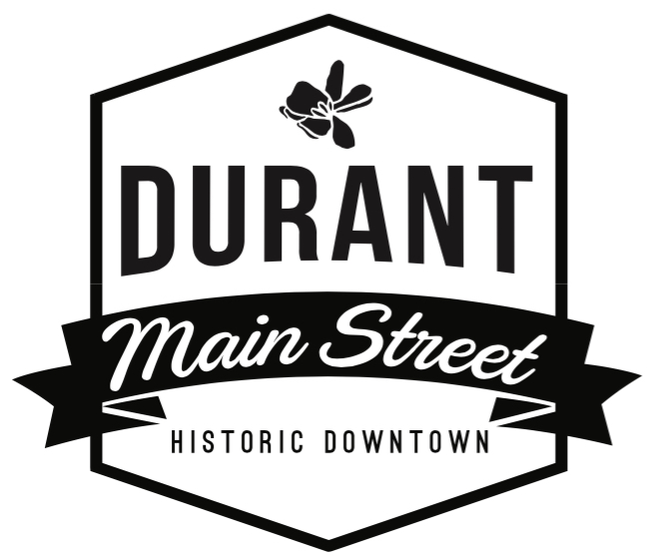
For questions, please contact:
Durant Main Street
Amber Foster, Executive Director
manager@durantmainstreet.org | 580.924.1550

Sponsorship Form

Sponsor Business Name (as listed for advertising): __________________________________________________
Contact Person: __________________________________________________________________________
Mailing Address: __________________________________________________________________________
Phone: __________________________________ Email: _________________________________________
Sponsorship Package:______________________________________________________________________
Amount Due: _______________________________ Date Sold: ________________________________

Check or credit card payments accepted. Contact Durant Main Street at 580-924-1550 to securely process your credit card payment. Make checks payable to Durant Main Street. Payment for sponsorship must be completed within 10 days of Sponsorship pledge to secure sponsorship.
If mailing: Durant Main Street, 124 N. 2nd Avenue, Durant, OK 74701

Thank you for supporting Durant Main Street and the Blast from the Past Car Club!

